## **Sender Sheet**

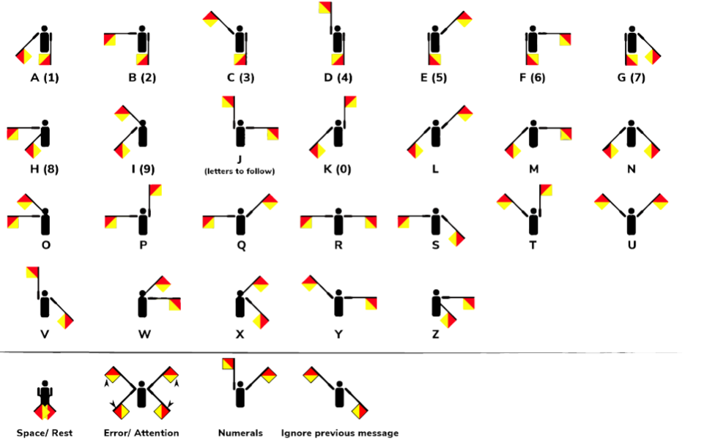

**Patrol**: _________________

**Sent Messages (record each message sent here)**

1 _______________________________________________________________________

2 _______________________________________________________________________

3 _______________________________________________________________________

4 _______________________________________________________________________

5 _______________________________________________________________________

6 _______________________________________________________________________

7 _______________________________________________________________________

8 _______________________________________________________________________

9 _______________________________________________________________________

10_______________________________________________________________________

11_______________________________________________________________________

12 ______________________________________________________________________

13 _______________________________________________________________________

14 _______________________________________________________________________

15 _______________________________________________________________________

16 _______________________________________________________________________

17 _______________________________________________________________________

18 _______________________________________________________________________

19 _______________________________________________________________________

20 _______________________________________________________________________

21 _______________________________________________________________________

22 _______________________________________________________________________

23 _______________________________________________________________________

24 _______________________________________________________________________

25 _______________________________________________________________________

26 _______________________________________________________________________

27 _______________________________________________________________________

28 _______________________________________________________________________

29 _______________________________________________________________________